System Design Phase
Phase 4
Hops — an offline-first campus safety network
Group 18
Victor · Hlonipha · Sade · Thrishen · Elijah · Nabihah · Jocelyn
IT Project · Semester 2, 2026
Submission date: 30 October 2026

Table of Contents
Right-click and choose “Update Field” to build the table of contents.

4.1 Introduction
This document is the system design for Hops, an offline-first campus safety and social application for Android. It follows the planning phase (Phase 2) and the analysis phase (Phase 3), and it specifies how the requirements established there are to be realised in software.
Phase 3 established what the system must do. The central requirement, and the one that constrains every design decision in this document, is that the system must continue to function with no internet connection, no mobile data and no cellular signal. A student who needs help is frequently a student whose phone cannot reach a server: in a basement corridor, out of data, or during the very incident that has disrupted the network. A design that assumes connectivity fails precisely when it is needed.

4.1.1 Purpose and scope of this document
This document covers the design of both applications delivered by the project — the student application and the administrator application — together with the backend that supports identity and moderation. It specifies:
- the overall system design and the design principles adopted (§4.2);
- the software, hardware and network architecture, with a class diagram (§4.3);
- the physical design: deployment, platform targets and runtime resources (§4.4);
- the database design, for both the on-device store and the server (§4.5);
- the program design, expressed as pseudocode for the algorithms that carry the system’s distinctive behaviour (§4.6);
- the interface design: navigation structure, input design and output design (§4.7);
- the security and backup design (§4.8).

4.1.2 Design goals
Five goals were derived from the Phase 3 requirements and are referred to throughout. Each design decision in this document is traceable to at least one of them.
# | Goal | Consequence for the design
G1 | Operate with no network of any kind | No server may sit on the path of any user-facing feature. Device-to-device radio is the primary transport, not a fallback.
G2 | An alert must travel beyond one device’s radio range | Receiving devices must re-broadcast what they hear, making the network a relay mesh rather than a set of point-to-point links.
G3 | The system must not become a tracking device | A continuously broadcasting application cannot carry a stable identifier. Identity on the air must rotate.
G4 | An alert from a stranger must be verifiable offline | Asymmetric signatures, with public keys cached on the device in advance of any need to verify them.
G5 | Degrade honestly, never silently | Where the platform cannot deliver a capability, the system must report that rather than present an action that quietly does nothing.
Table 4.1 — Design goals carried forward from the analysis phase.

4.1.3 Design constraints
Three constraints are fixed and not open to design trade-off. They are stated here because much of what follows is incomprehensible without them.
The advertisement budget. A Bluetooth Low Energy advertisement packet is capped by specification at 31 bytes. After the service identifier, the local-name header and a transmit-power structure that many Android chipsets append regardless of what the application requests, 26 bytes remain. The design budgets 24, retaining two bytes of margin. An over-long payload does not truncate: the entire advertisement is rejected by the radio and the message is never transmitted.
The peripheral role is not universal. Transmitting a BLE advertisement requires the Bluetooth peripheral role, which a significant proportion of budget and older Android handsets do not implement. Such a device can receive every message and transmit none. The design must detect this and say so (goal G5).
Runtime permissions are version-dependent. The Android 12 Bluetooth permissions do not exist below API 31. Requesting them unconditionally causes the permission framework to record them as permanently denied, with no dialog shown and no entry in system settings for the user to correct. Permission requests must therefore be gated on the runtime API level.

4.2 System Design
Hops is designed as a decentralised, peer-to-peer system with a deliberately minimal central component. This section describes the proposed system as a whole; the sections that follow decompose it.

4.2.1 Description of the proposed system
The system comprises three deployable parts:
Part | Description | Deployment
Student application | The primary application. Provides the radar, contacts and 1:1 chat, community alerts, the Emergency Flare, and a catalogue of eight optional features. | Android APK, entry point lib/main.dart
Administrator application | A deliberately thinner application for campus staff: composes official alerts, reviews reported content, warns and bans accounts, and reads the action log. | The same APK, entry point lib/main_admin.dart
Identity and moderation backend | A hosted PostgreSQL database holding accounts, public keys, roles and moderation state. It is not on the path of any peer feature. | Supabase (managed PostgreSQL)
Table 4.2 — The three deployable parts of the system.
The two applications are a single package. They are not separate build flavours. Dart permits multiple entry points into one package, and the administrator application reuses the shared identity, cryptography and Bluetooth primitives rather than reimplementing them. The practical consequence is that the two applications share one Android manifest, so anything declared natively for one is visible to the other. Where that sharing would cause a conflict — notification channels, which Android makes immutable once created — the two entry points use distinct identifiers.

4.2.2 Modularisation
The design is modular along two axes. Vertically it is layered (§4.3.1): presentation calls services, services call domain utilities and persistence, and no layer calls upward. Horizontally the user-facing functionality is divided into a catalogue of independent features.
The feature catalogue is a design decision, not merely an implementation detail. Eight features are optional: the user adds the ones they want and the rest are absent from the interface entirely. This addresses a requirement that is specific to a safety application — an interface crowded with mini-applications is an interface in which the two things that matter cannot be found quickly.
Feature | Function | Transport
Watch Me | A nominated contact is alerted if the user drifts out of range or disappears abruptly. | BLE name + seed
Vibe Check | Anonymous crowd-level reports for a location, valid for five minutes. | BLE name
Lost & Found | Lost or found item posts that relay hop-to-hop, valid for 24 hours. | BLE name, chunked
Study Bunny Finder | Anonymous broadcast of the module being studied, valid for five minutes. | BLE name
Hops Share | File and quick-note transfer to a nearby device, with progress in both directions. | Nearby Connections
Task Tracker | Assignments, deadlines and a calendar. Entirely local. | None (local only)
Hops Hopper | An arcade game paying the in-app currency. | None (local only)
Hops Wordle | A per-user daily word puzzle with streak tracking. | None (local only)
Table 4.3 — The optional feature catalogue.
Functionality that is always present, and deliberately not in the catalogue: the radar (the home screen), contacts and 1:1 chat, community alerts, the Emergency Flare, the cosmetics shop, and the profile and accessibility screens. A safety feature a user can remove is not a safety feature.

The offline assistant
A built-in assistant, presented to the user as a contact named Hops that is present from first launch, answers questions about the application and about campus safety procedure. It is a keyword-matched lookup over a bundled knowledge base of 62 entries, not a language model, and it is designed that way deliberately: the moment a safety application most needs to answer a question is the moment the network is unavailable, so the whole path must work with the radio off and no backend reachable.
An earlier design attempted to load a quantised Gemma model on device. That approach was abandoned rather than stubbed, for three independent reasons: the inference library in use reads a different model format, its interpreter takes numeric tensors rather than prompt strings, and a model of that size exceeds the Android base-module limit. Recording this is the honest position — the assistant is a lookup, and the design does not claim otherwise.
Replies can optionally be spoken aloud. This is an accessibility provision rather than a cosmetic one, and it is configured separately from the appearance settings because it changes behaviour rather than appearance.

Relay route scoring
Where more than one neighbour could carry a relayed message, a scoring function ranks candidates on signal strength and reported battery level. An optional on-device model is consulted when present; when it is absent — which is the expected state, not an error — the function falls back to a heuristic. This is an instance of the degrade-rather-than-fail principle in §4.2.3.

4.2.3 Design principles adopted
Broadcast before connection. Establishing a Bluetooth connection takes seconds per device and must be repeated for each peer. For an emergency alert that cost is unacceptable, so the primary mechanism is connectionless: a device re-advertises its own name, and every device in range reads it passively. One transmission reaches every listener simultaneously.
Degrade, do not disappear. Where a secondary channel carries supplementary data, the feature it supports must remain functional without it. Signature chunks, for instance, ride a parallel manufacturer-data field; if that field is dropped by a given handset, the alert still arrives and is displayed as unverified rather than not arriving at all.
Spend scarce resources where forgery causes harm. Cryptographic signatures do not fit within the advertisement budget for every message type. They are therefore applied to the two message types where a forgery would be dangerous — the Emergency Flare and the Official Alert — and not to the remainder. This is a conscious scoping decision and is recorded as a limitation in §4.8.
Local by default. Feature data is written to the device and nowhere else. The strongest confidentiality guarantee available to the design is that most of the data does not exist centrally to be disclosed.

4.3 Architectural Design

4.3.1 Software architectural design
The application is organised into four layers above the platform channel boundary. Calls travel downward only: a service may call a utility or the persistence layer, but no service holds a reference to a screen, and no utility is aware of the application shell.
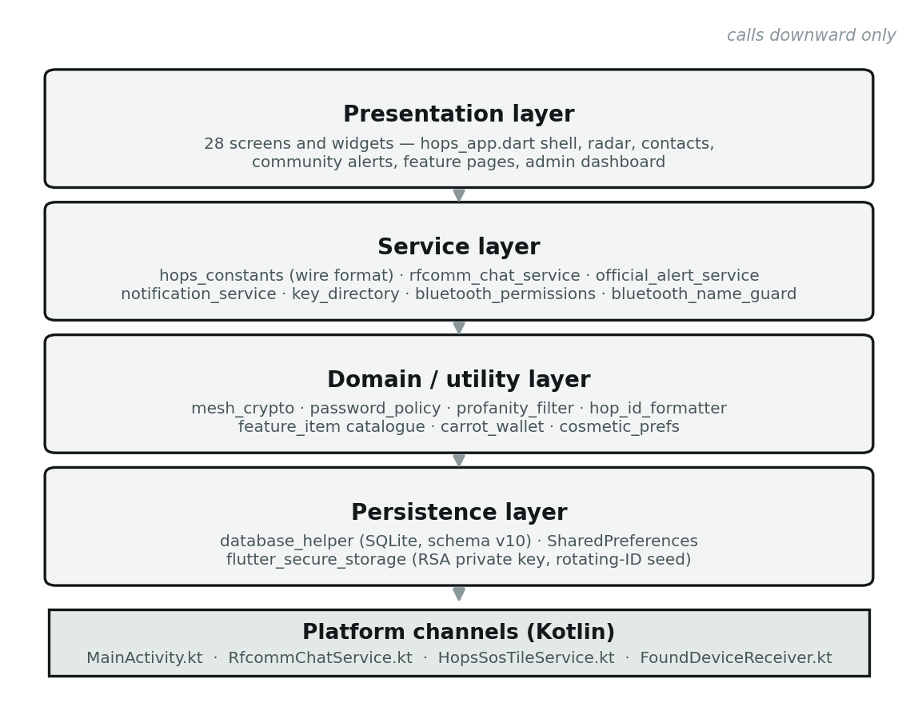
Figure 4.1 — Layered software architecture of the Hops client.
The application shell, implemented in hops_app.dart, is the one component that orchestrates across layers. It owns the Bluetooth advertising and scanning lifecycle, the tabbed navigation, and the dispatch of incoming advertisements to the appropriate handler. Its size is a known characteristic of the design: concentrating radio state in one place is what allows the system to guarantee that two concurrent alerts cannot interfere with each other (§4.6.3), but it makes that file the largest single module in the project.

Module responsibilities
Module | Responsibility
hops_constants.dart | The wire format. Encoding and decoding of every advertisement payload, the byte budgets, chunking and reassembly, rotating-token derivation, and signature chunking. The single source of truth for what may go on the air.
bluetooth_name_guard.dart | Sole owner of reads and writes to the Bluetooth adapter name. Captures and restores the user’s real device name around every advertisement.
bluetooth_permissions.dart | The only permitted route to a runtime permission request. Gates the Android 12 Bluetooth permissions on the runtime API level.
mesh_crypto.dart | Password salting and hashing, RSA keypair generation, and derivation of the pairwise symmetric key shared by two devices.
key_directory.dart | Local cache of public keys, synchronised opportunistically from the backend so that verification can proceed offline.
notification_service.dart | The alert registry. Allocates a notification identifier per distinct alert so that concurrent alerts stack rather than overwrite.
rfcomm_chat_service.dart | Dart-side wrapper over the native RFCOMM socket, including the profile exchange that carries avatar, biography and rotating-ID seed.
official_alert_service.dart | Composition and broadcast of administrator alerts. Reachable only from the administrator entry point.
database_helper.dart | Singleton wrapper over the on-device SQLite database, including schema versioning and migration.
hops_engine.dart | The offline assistant: keyword lookup over the bundled knowledge base, optional text-to-speech, and the relay route-scoring function.
profanity_filter.dart | Offline filter applied wherever free text is about to be shown to another user. Bundled word list, identical on every device, since there is no moderation service to call.
vibe_report_store.dart, lost_found_store.dart, study_bunny_store.dart | Application-wide stores for the three broadcast-and-expire feature types, so that reports heard while a screen is closed are not lost.
Table 4.4 — Principal modules and their responsibilities.

Class diagram
Figure 4.2 shows the core domain classes and their dependencies. The shell depends on the services; the services are leaves and hold no reference back to the shell. This is what permits the administrator entry point to reuse them without instantiating the student application.
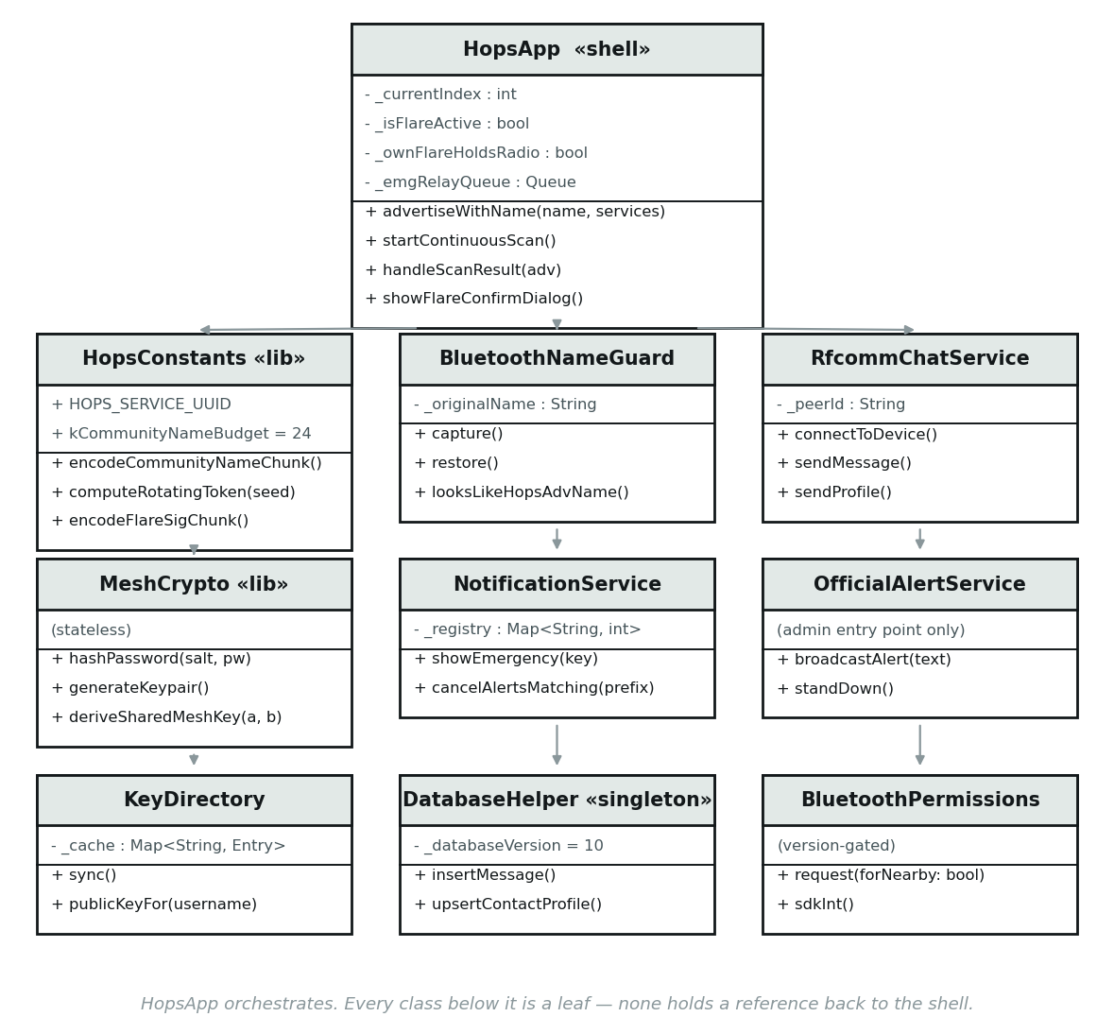
Figure 4.2 — Class diagram of the core domain.

4.3.2 Hardware architectural design
The hardware architecture is deliberately unremarkable, and that is the point: the system requires no infrastructure of its own. There is no campus server, no gateway, no beacon hardware to install and no coverage map to plan.
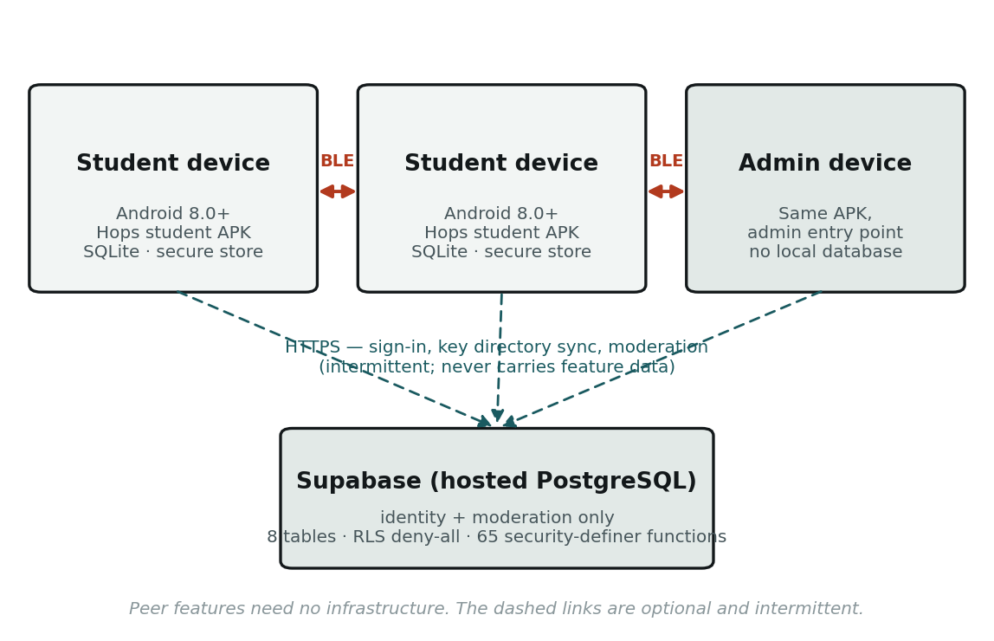
Figure 4.3 — Deployment view. Solid links are device-to-device radio; dashed links are optional and intermittent.
Element | Requirement | Justification
Student device | Android 7.0 (API 24) or later; Bluetooth 4.0+ | minSdkVersion 24 / targetSdkVersion 36 as declared in the merged manifest. The floor is set by the plugin set rather than by any deliberate choice.
Transmitting device | Bluetooth peripheral role | Required to advertise. Devices without it can receive but not send, and the application reports this at startup rather than failing silently.
Administrator device | As above | The administrator application is the same package.
Server | None owned by the project | A managed PostgreSQL instance is consumed as a service. No hardware is provisioned, and none is required for peer features to operate.
Table 4.5 — Hardware requirements and their justification.

4.3.3 Network architectural design
Three distinct network mechanisms are used, selected for three incompatible communication shapes. Using one mechanism for all three would require either a chat that cannot hold a sentence or an alert that must connect to each recipient in turn.
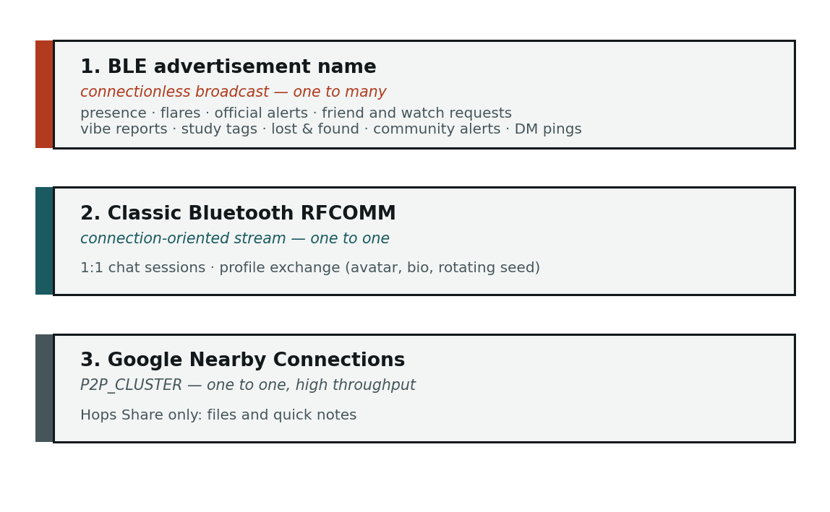
Figure 4.4 — The three communication mechanisms and what each carries.

Mechanism 1 — the advertisement name as the wire protocol
The primary mechanism does not open connections. Each device repeatedly re-advertises its BLE local name as a short coded string, and every other device scans passively and parses the names it observes. A prefix identifies the message type; the remainder is the payload.
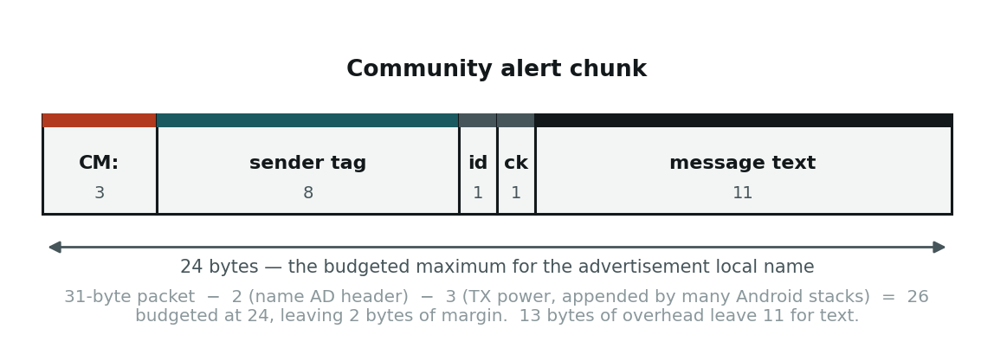
Figure 4.5 — Byte layout of a community alert chunk within the 24-byte budget.
Because 13 bytes of a 24-byte name are overhead, 11 bytes remain for text. Longer messages are divided across up to eight chunks and reassembled by the receiver, giving a maximum of 88 bytes per message. The chunking algorithm must never divide a multi-byte character across a chunk boundary, since each chunk is decoded independently (§4.6.2).
Prefix | Message type | Prefix | Message type
HPS: | Presence beacon (rotating token) | CM: / CA: | Community alert, student / admin
EMG: / EMG_OFF: | Emergency Flare and stand-down | CX: | Community alert deletion
ADM: / ADM_OFF: | Official Alert and stand-down | DM: | Direct message, chunked
FR: / FA: | Friend request and acceptance | LNF: / LNR: | Lost & found post, resolution
WR: / WA: | Watch Me request and acceptance | VBT: / VBX: | Vibe Check tag and expiry
ACK: / HOP: | Manual pairing-code handshake | SBF: SBI: SBC: SBX: | Study Bunny Finder
CHT: | Chat ping (truncated username) | TAG: / GAME_ | Reserved; receive handlers only (see note)
Table 4.6 — Advertisement prefixes and the message types they identify.
A note on the reserved prefixes. The TAG: and GAME_ handlers remain in the scan dispatcher from an infection-tag game that was implemented and then withdrawn from the design. The screen is no longer referenced by any navigation path and the catalogue entry is commented out, so no device can start a game; the handlers are therefore unreachable in practice and are recorded here as reserved rather than live. They are listed because a future reader of the dispatcher will otherwise find two prefixes this document does not explain.

The secondary channel
Where the name is already full, a manufacturer-data field on the same advertisement carries the remainder: signature chunks, a Watch Me seed, a discoverable name, or a game tag. There is exactly one such field per advertisement, so these uses are mutually exclusive by construction.
Everything carried on this channel is supplementary by design. Each item enriches a message whose primary signal already rides the name, so if the field is dropped on a given handset the feature degrades rather than disappears. An earlier iteration of community alerts rode this channel with no such fallback and was the one feature that failed outright; that experience is the origin of the principle stated in §4.2.3.

Mechanisms 2 and 3
A conversation requires a reliable, ordered, bidirectional stream, which a broadcast cannot provide. 1:1 chat therefore uses a classic Bluetooth RFCOMM socket, implemented natively in Kotlin and bridged to Dart per peer. The sockets are deliberately insecure RFCOMM on both ends: the secure variant initiates operating-system pairing, which presented the user with an unsolicited pairing dialog on every connection. Nothing in the design depends on a bond existing.
File transfer requires throughput and resumable progress reporting, so Hops Share uses Google Nearby Connections, which negotiates the fastest transport available rather than being restricted to Bluetooth. Nearby Connections and the BLE mesh contend for the same radio, so entering the sharing screen suspends the application’s own advertising and scanning, and leaving it resumes them.

4.4 Physical Design
The physical design describes how the logical design is realised on actual devices: what is installed, where data physically resides, and what runtime resources are consumed.

4.4.1 Distribution and installation
Both applications are delivered as a single Android package. Installation requires no app store, no account provisioning step and no server address to configure; the application is usable immediately after sign-up. Desktop builds for Windows exist for development and demonstration purposes and substitute an FFI SQLite implementation for the mobile one.

4.4.2 Physical data placement
Store | Physical location | Contents | Leaves the device
SQLite | MeshNetwork.db in the application documents directory | Message log and relay queue, crowd reports, tasks, contact profiles | Never
SharedPreferences | Platform preference store | Session token, username, avatar path, enabled features, theme, currency balance, cosmetics, game progress, one-time flags | Never
Secure storage | Android Keystore-backed store | RSA private key, rotating-ID seed | Never, after generation
PostgreSQL | Managed Supabase instance | Accounts, salted password hashes, public keys, roles, session tokens, moderation records, administrator action log | This is the only off-device state
Table 4.7 — Physical placement of each data store.
A note on file naming. Avatar and image files are written under timestamped filenames and the previous file deleted, never overwritten in place. The framework’s image cache keys a decoded image by path and does not observe that the bytes beneath an unchanged path have changed, so overwriting in place displays the first image indefinitely.

4.4.3 Runtime resources and background operation
A foreground service keeps Bluetooth scanning active while the application is backgrounded, so that an Emergency Flare raised nearby is received even when the screen is off. This is the principal continuous cost the design imposes, and it is accepted because an alert that is only received while the application is in the foreground would be of little value.
Resource | Design decision
Radio duty cycle | The idle state is a low-power presence beacon plus a filtered scan. Transient advertisements last a few seconds and then revert to the beacon.
Scan filtering | The continuous scan is filtered on the Hops service identifier in hardware, so unrelated Bluetooth traffic is rejected before it reaches the application.
Mutual exclusion | Nearby Connections sessions suspend the mesh timers, since both compete for the same radio.
Storage | Message rows carry a relay flag and are pruned; alerts self-expire. No store grows without bound.
Table 4.8 — Runtime resource decisions.

4.5 Database Design
The system has two databases with entirely different purposes, and the separation is itself a design decision. Feature data is local; only identity and moderation are central.

4.5.1 On-device database
The local store is a SQLite database, currently at schema version 10. It holds four tables.
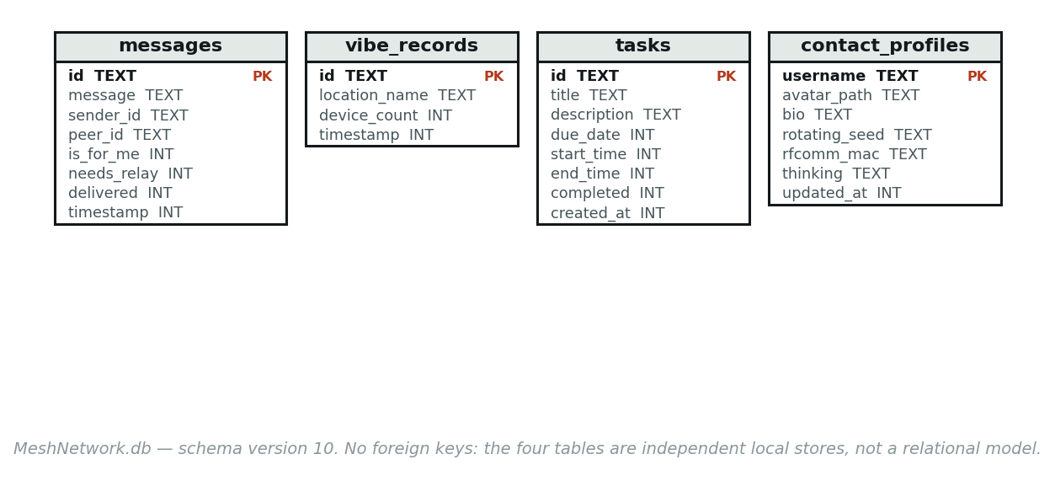
Figure 4.6 — On-device SQLite schema (MeshNetwork.db, version 10).
Table | Purpose | Notable columns
messages | The 1:1 chat log and the mesh relay queue, in one table. | peer_id scopes a conversation independently of direction, because sender_id on an outgoing row is the local user. needs_relay marks a message awaiting onward transmission; delivered distinguishes sent from pending.
vibe_records | Saved crowd-level reports for the user’s own history. | location_name, device_count, timestamp.
tasks | Task Tracker entries. | due_date, start_time and end_time are nullable; completed defaults to 0.
contact_profiles | Locally cached details of a contact, learned by direct exchange. | rotating_seed resolves that contact’s changing presence beacon; rfcomm_mac allows a later chat to connect directly; avatar_path and bio are cosmetic.
Table 4.9 — Tables in the on-device database.

Design decisions and integrity
No foreign keys, deliberately. The four tables are independent local caches, not a relational model. A contact profile may legitimately exist with no messages, and a message may legitimately arrive from a peer with no cached profile. Imposing referential integrity here would reject valid states produced by a network in which arrival order is not guaranteed.
Versioned migration is mandatory. Each schema change increments the version and adds a migration branch. The creation path is never edited alone once a version has shipped, since an installed device will never execute it.
A single source of truth for the file path. The database path is resolved through one function. An earlier design allowed two components to reconstruct the path independently, and they produced different directories — with the result that a sign-out intended to erase local data deleted a file that did not exist, while the real database survived into the next account on the same device.

4.5.2 Server-side database
The server holds eight tables. Figure 4.6 shows their relationships; the full access-control design is in §4.8.
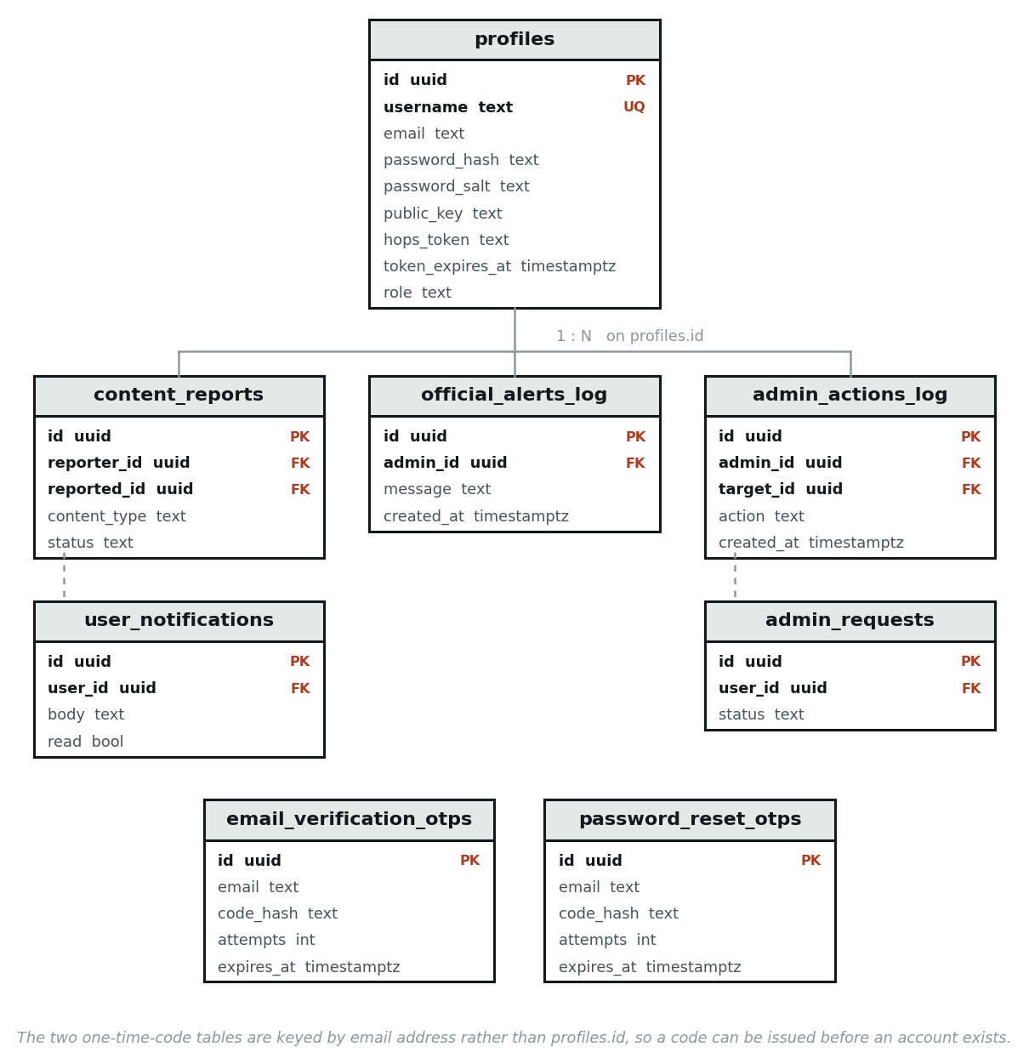
Figure 4.7 — Entity-relationship diagram of the server-side database.

Integrity and constraints
Constraint | Where | Purpose
Primary keys | All eight tables | UUID surrogate keys throughout.
Unique | profiles.username | Usernames identify an account to other users and must be unique.
Foreign keys | All child tables reference profiles.id | Moderation records and notifications must refer to a real account.
Expiry columns | Both one-time-code tables | Codes are valid only within a window; expiry is enforced server-side, never by the client.
Attempt counters | Both one-time-code tables | Limits brute-force guessing of a code.
Append-only by convention | admin_actions_log | No function exposes an update or delete, so the audit trail cannot be rewritten through the public surface.
Table 4.10 — Data integrity constraints on the server-side database.
Normalisation: the schema is in third normal form. Moderation records reference accounts by key rather than duplicating usernames, so a username change cannot orphan an audit entry or leave two records disagreeing about who was involved.

4.6 Program Design
This section gives the procedural design for the algorithms that carry the behaviour most specific to this system. Routine create-read-update-delete logic is omitted; what follows is the design that a reimplementation would have to reproduce in order to be correct.

4.6.1 Deriving a rotating presence identifier
Goal G3 requires that a continuously broadcasting device must not carry a stable identifier. The presence beacon therefore carries a token derived from a secret seed and the current time window. The seed is generated at sign-up, held in secure storage and never transmitted. Only a device that has previously been given the same seed — exchanged pairwise over an already-established chat session — can recompute the token and recognise the sender.
FUNCTION ComputeRotatingToken(seed, atTime)
window <- FLOOR(atTime.millisecondsSinceEpoch / WINDOW_MS) // WINDOW_MS = 15 min
mac <- HMAC_SHA256(key := seed, message := STRING(window))
RETURN BASE64URL(mac[0 .. 5]) WITHOUT padding // 6 bytes -> 8 characters
END FUNCTION
FUNCTION MatchesRotatingToken(seed, candidateToken)
// Accept the previous window as well, so a device checked moments after a
// rollover is still recognised without requiring synchronised clocks.
IF ComputeRotatingToken(seed, NOW) = candidateToken THEN RETURN TRUE
IF ComputeRotatingToken(seed, NOW - WINDOW) = candidateToken THEN RETURN TRUE
RETURN FALSE
END FUNCTION
A fifteen-minute window is short enough to defeat logging beacons at fixed points to reconstruct a person’s movements, and long enough that resolving a known contact costs one computation per window rather than one per observation. The same approach and a comparable interval are used by the Apple/Google exposure-notification scheme.

4.6.2 Splitting a message to fit the advertisement budget
A message longer than the 11-byte text budget must be divided. The division is by UTF-8 byte length, not by character count, and a multi-byte character must never be split across two chunks: each chunk is decoded independently on arrival, and half a character decodes to nothing useful.
FUNCTION SplitMessage(text)
chunks <- empty list
buffer <- empty string
bytes <- 0
FOR EACH character ch IN text // iterate runes, not code units
chBytes <- LENGTH_IN_UTF8_BYTES(ch)
IF bytes + chBytes > TEXT_BUDGET THEN // TEXT_BUDGET = 11
APPEND buffer TO chunks // close the chunk BEFORE adding ch
buffer <- empty string
bytes <- 0
END IF
buffer <- buffer + ch
bytes <- bytes + chBytes
END FOR
IF buffer is not empty THEN APPEND buffer TO chunks
RETURN FIRST MAX_CHUNKS OF chunks // MAX_CHUNKS = 8
END FUNCTION
The chunk index and the total count are packed into six bits each within a single character of the encoded name, which is what fixes the maximum at eight chunks and therefore the maximum message length at 88 bytes.

4.6.3 Raising, relaying and standing down an Emergency Flare
This is the most safety-critical procedure in the system, and the case of two people raising an alert simultaneously is treated as normal rather than exceptional. Figure 4.7 shows the message sequence; the pseudocode that follows gives the receive-side logic.
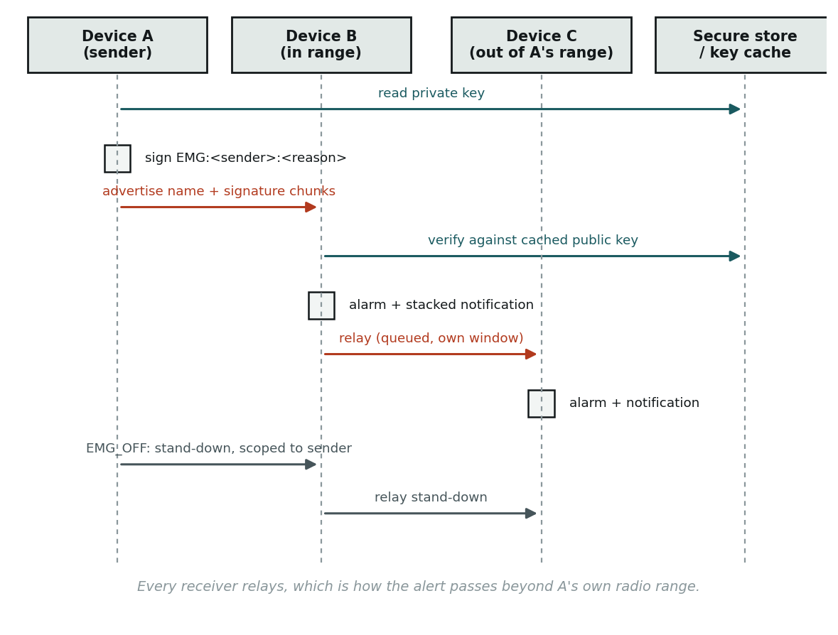
Figure 4.8 — Message sequence for an Emergency Flare, including relay beyond the sender’s own range.
PROCEDURE RaiseFlare(reason)
IF NOT PeripheralRoleSupported() THEN
INFORM user the device cannot transmit; ABORT // goal G5
END IF
name <- "EMG:" + TRUNCATE(username, 8) + ":" + TRUNCATE(reason, 14)
signature <- SIGN(privateKey, name) // RSA-2048, ~256 bytes
ownFlareHoldsRadio <- TRUE // outranks relaying anyone else's
FOR EACH chunk IN SPLIT(signature, 18 bytes)
ADVERTISE(name, manufacturerData := EncodeSigChunk(chunk))
END FOR
AFTER 60 SECONDS: StandDown()
END PROCEDURE
PROCEDURE OnAdvertisementReceived(adv)
IF adv.name STARTS WITH "EMG:" THEN
IF Seen(adv.name) THEN RETURN // dedup on the FULL string
Register(adv.name)
verified <- VerifySignature(adv, KeyDirectory.publicKeyFor(SenderOf(adv.name)))
NotificationService.Show(key := adv.name, verified := verified)
EnsureAlarmSounding() // never restarts an already-looping siren
ScheduleExpiry(adv.name, AUTO_EXPIRY) // a stand-down may never arrive
IF NOT ownFlareHoldsRadio THEN
EnqueueRelay(adv) // queued: one radio, one window each
END IF
ELSE IF adv.name STARTS WITH "EMG_OFF:" THEN
sender <- SenderOf(adv.name)
NotificationService.CancelMatching("EMG:" + sender + ":") // trailing colon
SyncAlarmState() // stops the siren iff the registry is empty
END IF
END PROCEDURE

Invariants this design must preserve
Each of the following is a correctness property of the procedure above. They are stated explicitly because each is easy to violate with a change that appears locally harmless.
Invariant | Why it is required
Relays are queued, never concurrent | There is one advertisement slot. Two independent advertise-then-revert cycles overwrite each other, and the first cycle’s timer then reverts the radio mid-way through the second.
The device’s own flare outranks relaying another | No other device can transmit this device’s flare, whereas another device’s flare is already being relayed by every other receiver.
Alerts are keyed by the complete advertisement string | The string is unique per sender and reason, so concurrent alerts receive distinct notification identifiers and stack instead of overwriting.
A stand-down is scoped to its own sender | Cancelling every active alert because one person stood down would silence a genuine emergency.
One siren regardless of alert count, stopped in one place | If the alarm were started and stopped from multiple sites, the audible state and the notification registry would drift apart.
Every alert expires independently | A stand-down is an ordinary broadcast and may never arrive. Without expiry an orphaned alert would sound indefinitely.
Table 4.11 — Correctness invariants of the concurrent-alert design.

4.6.4 Protecting the device’s Bluetooth name
On Android the advertised local name is the device’s system Bluetooth name; the platform provides no separate field. Advertising a payload therefore renames the handset for the duration. The design isolates all adapter-name access behind one component.
PROCEDURE AdvertiseWithName(payload, services)
NameGuard.CaptureOriginalIfUnknown()
SET adapterName <- payload
START advertising(payload, services)
AFTER 500 ms: NameGuard.Restore() // payload is already in the live advertisement
END PROCEDURE
PROCEDURE NameGuard.CaptureOriginalIfUnknown()
IF stored original EXISTS THEN RETURN
current <- READ adapterName
IF LooksLikeHopsPayload(current) THEN RETURN // critical: see below
PERSIST current AS original // to durable storage, not memory
END PROCEDURE
The refusal to record a payload as the original is essential, not defensive. Without it, an application killed mid-advertisement reads a protocol string from the adapter on next start, stores it as the user’s real name, and every subsequent restore faithfully rewrites a protocol string — turning the cleanup mechanism into the thing that keeps the name wrong. The original must also be persisted durably rather than held in memory, for the same reason.
What this design cannot achieve is stated plainly in §4.8: while an advertisement is live, the payload is the device name and is visible to anyone scanning. Removing that exposure requires moving payloads off the advertisement name entirely, which is a redesign rather than a refinement.

4.6.5 Requesting runtime permissions
The permission routine is given here because an incorrect version gate produces an unrecoverable state for the user, not merely a failed request.
FUNCTION RequestBluetoothPermissions(callerNeedsNearbyWifi)
sdk <- GetAndroidSdkInt() // via platform channel; unknown is treated as modern
REQUEST location // required on every supported version for BLE scanning
IF sdk >= 31 THEN // Android 12: these permissions did not exist before
REQUEST bluetoothScan, bluetoothAdvertise, bluetoothConnect
END IF
IF sdk >= 33 AND callerNeedsNearbyWifi THEN
REQUEST nearbyWifiDevices // Nearby Connections callers only
END IF
RETURN all requested permissions granted
END FUNCTION
Below API 31 the Android 12 permissions resolve to no manifest entry, and the permission framework records a permission with no manifest entry as denied. The user is shown no dialog and finds no corresponding switch in system settings, so the denial cannot be cleared by any action available to them. An unknown version is treated as modern, because over-requesting is recoverable by the user and under-requesting is not.

4.7 Interface Design

4.7.1 Menu interface design
Navigation is deliberately shallow. The application resolves at launch to one of two subtrees depending on whether a session token is present, and the authenticated subtree is a five-tab shell with no nested navigation bar.
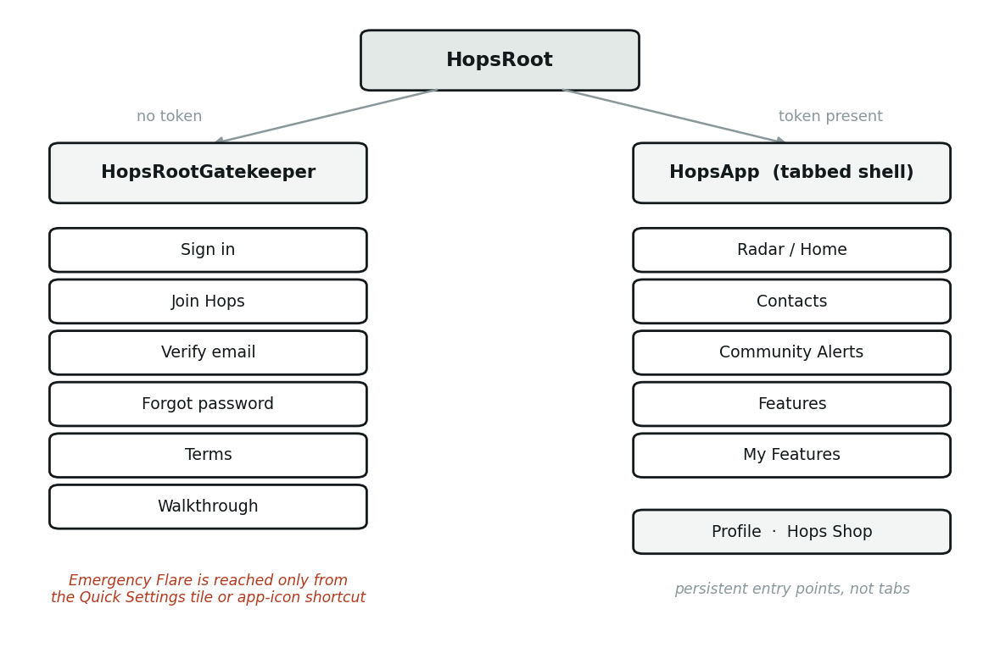
Figure 4.9 — Navigation structure of the student application.
Tab | Purpose | Interaction
Radar / Home | Nearby devices rendered as anonymous dots; the default landing screen. | Passive display, with a manual rescan control.
Contacts | Known contacts, friend requests, and entry to 1:1 chat. | Read and act.
Community Alerts | Broadcast messages from nearby users and administrators. | Read-only for students; only the administrator application composes.
Features | The catalogue of optional features available to add. | Browse and add.
My Features | The features this user has enabled. | Launch.
Table 4.12 — The five tabs of the student application.
A navigation constraint worth recording. The tabs are driven by a paged view with an index held in state. Setting that index alone moves the navigation indicator without changing the visible page, leaving the two disagreeing until the user interacts. Any programmatic tab change must drive the page controller, not the index.
The Emergency Flare has no menu entry at all. It is reached only from the Android Quick Settings tile or a long press on the application icon, and both routes open the same confirm-then-reason dialog. A screen that must be unlocked, opened and navigated is not reachable in the circumstance the feature exists for. The dialog is mounted on the application shell rather than on any tab, so that it renders above whatever screen is currently displayed and does not change tabs — relocating the user mid-emergency is both disorienting and slow.
A volume-button gesture was designed, implemented and then withdrawn. It functioned on some handsets and silently did nothing on others, because manufacturer software layers intercept volume keys before the application receives them. For a safety control this is the worst possible property: it teaches the user a gesture they will then rely on. The design records that no such gesture should be reintroduced without a runtime means of confirming the key event actually reaches the application.

4.7.2 Input design
Inputs are designed around two constraints: the user may be in a hurry, and the payload may have to fit in eleven bytes.
Input | Control | Validation and constraint
Username | Single-line text, sign-up only | Character-class rules; uniqueness enforced server-side. Truncated to 8 characters on the air, which the design accepts as a known collision risk (§4.8).
Password | Obscured text with a visibility toggle and a live strength meter | Length and character-class rules, plus a weak-password blocklist evaluated against a folded form of the input so that common substitutions are also rejected. The blocklist is checked before the character-class rules, since below them it would be unreachable.
Flare reason | Short preset list plus free text | Truncated to 14 characters. Presets exist because typing under duress is slow.
Community alert | Multi-line text | Divided into up to six parts of 33 bytes; the user is told when a message was too long and what was sent.
Crowd level | Four-value selector (Quiet / Moderate / Busy / Packed) | A closed set, so the value fits the budget and needs no free-text parsing.
Task | Title, description, date and time pickers | Title required; all other fields optional.
Avatar | Image picker | Written under a timestamped filename; the previous file is deleted (§4.4.2).
Table 4.13 — Input design.

4.7.3 Output design
Outputs are designed so that the urgency of the presentation matches the urgency of the information, and so that the system never presents certainty it does not have.
Output | Presentation | Design rationale
Emergency Flare received | Full-width banner, looping siren, system notification | Must be noticed when the device is in a pocket and the screen is off. One siren serves any number of concurrent alerts; notifications stack.
Verification state of an alert | Explicit “verified” marker, or its absence | An unverified alert is shown as unverified rather than withheld or presented as trustworthy.
Official Alert | Distinct styling and the administrator’s title | Distinguishes an institutional message from a peer message.
Nearby devices | Anonymous dots with relative signal strength | Shows proximity without identity, consistent with goal G3.
Transmit incapability | A one-time warning at startup | A device without the peripheral role is told so, rather than being offered a control that would do nothing (goal G5).
Message delivery | Pending and delivered states distinguished in the chat log | On an intermittent link the user must be able to tell what has actually left the device.
Crowd reports | Aggregated level per location with an age indicator | A five-minute-old report and a five-second-old report are not equivalent.
Table 4.14 — Output design.

4.7.4 Accessibility and consistency
The visual design is data-driven: a theme catalogue supplies colour schemes, and the selected theme is applied through a single notifier read by both entry points, so the two applications cannot drift apart visually. Font family and text scale are user-adjustable. These provisions were extended in direct response to the acceptance testing conducted in August 2026, in which visual design scored lowest of all the item clusters and the most frequent request was for a dark theme and a wider choice of colour.

4.8 Security and Backup Design
This section was drafted alongside the implementation of the access-control model and the backup procedure. Its source of record is docs/report-4.8-security-and-backup-design.md in the project repository; the two are kept in step.

4.8.1 Scope and assets
Hops is offline-first. Almost all of its data never reaches a server at all, and that architectural fact does more for the system's security posture than any control described below. Establishing what actually needs protecting therefore comes first.
Server-side assets (Supabase, PostgreSQL). Eight tables, holding identity and moderation state only:
Table | Holds | Sensitivity
profiles | username, email, salted password hash, salt, session token, RSA public key, role | High
admin_actions_log | audit trail of every moderator action | High (integrity)
content_reports | user-submitted reports of content and behaviour | High
email_verification_otps | one-time codes, attempt counters, expiry | High (short-lived)
password_reset_otps | one-time codes, attempt counters, expiry | High (short-lived)
official_alerts_log | record of admin-issued campus alerts | Medium (integrity)
user_notifications | moderation outcomes delivered to a user | Medium
admin_requests | pending requests for elevated privilege | High

On-device assets. Everything else: the message log and relay queue, vibe records, tasks and contact profiles (SQLite via sqflite), and small state in SharedPreferences (session token, avatar path, enabled features, carrot balance, cosmetics, game progress). Additionally, the device's RSA private key, held in flutter_secure_storage.
Assets deliberately not held anywhere central. Chat content, location or proximity history, friend graphs, emergency-flare content, and Lost & Found entries. There is no server-side data plane; peer features operate entirely over local Bluetooth. A total compromise of the Supabase project would therefore expose account records and moderation history, but would not expose a single message, a single flare, or any record of who was near whom.

4.8.2 Access control design

The problem the design responds to
Supabase ships an anonymous API key inside the client application. In Hops that key is in client/.env and is present in every installed copy of the app. It must therefore be treated as public knowledge, not as a credential.
By default, Supabase grants full privileges on new public-schema tables to the anon and authenticated roles. Before migration 0001_lockdown_profiles.sql, this meant that anyone extracting the key from the APK held direct SELECT, INSERT, UPDATE, DELETE and TRUNCATE on profiles — including the password hash and session token columns.
Row Level Security alone cannot resolve this. The original sign-in flow issued select().eq('username', x) and compared the hash on the client. Any policy permissive enough to return that row is equally permissive when the same query is issued with no filter at all.

The design adopted: deny-all plus a function surface
The database is configured so that no table is reachable directly, and every operation is a named, typed, server-side procedure.
Control | Count | Effect
Tables with RLS enabled | 8 (all) | Non-owner roles are denied by default
CREATE POLICY statements | 0 | Nothing re-opens that default
SECURITY DEFINER functions | 65 | The entire permitted operation set
REVOKE statements | 74 | Default grants explicitly withdrawn
GRANT EXECUTE statements | 61 | Each function opened deliberately

RLS enabled with zero policies is a deny-all posture, not an oversight. The client cannot read profiles; it calls signin_hops_user, which runs with the definer's privileges, performs the comparison server-side, and returns only the safe subset of columns. The password hash goes in and never comes back out.
Where genuinely public data is required — the public-key directory used for Emergency Flare signature verification — it is exposed through a narrowed view, profiles_public, projecting only {id, username, public_key}. Nothing sensitive is reachable through it.
Every function additionally sets search_path = public, which prevents a search_path manipulation attack against a SECURITY DEFINER routine.
This structure also removes SQL injection as a category rather than mitigating it: no user input is ever concatenated into a query. Every write is an RPC call with named, typed parameters.

Authentication
- Password storage. Passwords are hashed on the client before transmission, so the plaintext never reaches the server — a deliberate rule inherited from 0001. Migration 0018_salted_password_hashing.sql added a per-account salt; because the client hashes first, the server cannot salt on the client's behalf, so the client requests the (non-secret) salt before hashing.
- Enumeration resistance. A salt lookup for an unregistered email returns a deterministic, salt-shaped value derived from the email itself, rather than an error or an empty string. Sign-in errors are collapsed to a single message. Neither step reveals whether an account exists, and repeated lookups for the same absent email return the same value, so variation across calls does not leak either.
- Backward compatibility. Pre-migration accounts carry password_salt = '', which the hashing helper treats as a no-op prefix. Existing hashes keep matching; a real salt is adopted at the next password change.
- One-time codes. Both OTP flows (email verification, password reset) expire after 24 hours and lock after 5 failed attempts, bounding both brute force and the lifetime of a stale code.
- Sessions. A rotating hops_token is issued on sign-in and stored in SharedPreferences.

Key management
Each device generates an RSA keypair at sign-up. The public key is stored in profiles and distributed to peers through the key directory; the private key is written to flutter_secure_storage (backed by the Android Keystore) and is never transmitted after generation. It signs Emergency Flares and Official Alerts, which is what allows a receiving device to verify that an alert genuinely originated from the claimed sender — including while completely offline, since verification needs only the cached public key.

Privilege separation
The administrator application is a second Dart entry point in the same package. It authenticates against a profiles row with role = 'admin' and can never create one; administrator accounts are provisioned out-of-band. Every moderator action is written to admin_actions_log, producing a tamper-evident audit trail independent of the moderator's own account.

4.8.3 Known limitations
Stated explicitly, because a security section that claims no weaknesses is not credible.
Limitation | Consequence | Position taken
Sender tags on the BLE wire are truncated to 8 characters | Two users sharing those first 8 characters can cancel each other's alerts | Inherent to the advertisement size limit; not fixable in the notification layer
The anonymous key ships inside the app | Must be assumed public | Neutralised by the deny-all design above — the key grants only EXECUTE on vetted functions
Carrot balance is client-side only | A modified client can grant itself cosmetics | Accepted: carrots buy cosmetics only, with no real-money path into the app, so the worst case is free customisation, not fraud
debugUnlimitedCarrots is currently true | The economy is bypassed | Demo and QA convenience; must be set to false before any public release
The weak-password blocklist is unreachable | A capitalised variant of a blocked password is accepted | Resolved 2 September 2026. Found by the unit test suite: every blocklist entry is lowercase letters and digits, so each failed the uppercase rule first and the blocklist branch could never run — and the message it returned instead ("add a capital letter") described the exact edit that produced an accepted password. Fixed by checking the blocklist first and comparing a folded form (case dropped, non-alphanumerics stripped, common character substitutions reversed) by substring, so Password123! and P@ssw0rd1 are now caught
Advertising can fail silently on central-only hardware | Such a device receives alerts but cannot send | Detected at startup and surfaced to the user rather than failing quietly

4.8.4 Backup design

What requires backup
Only the Supabase database. On-device data is deliberately excluded: it is private to its device by design, and centralising it for backup would undo the privacy property that motivates the offline-first architecture. Loss of a device's local data is therefore an accepted outcome, and is stated to users rather than silently mitigated.
Source code is version-controlled in Git with a remote, which constitutes its own backup path and is not restated here.

Method
Logical backup using pg_dump, producing a plain-text SQL file containing both schema and data. This format was chosen over Supabase's managed snapshots for three reasons: it is portable to any PostgreSQL instance rather than tied to one project, it is human-readable and therefore inspectable and partially recoverable even if damaged, and it is available on the project's free tier, where managed point-in-time recovery is not.
Two scripts implement the procedure, in scripts/:
Script | Purpose
backup-db.ps1 | Takes and validates a dump
verify-backup.ps1 | Restores it into a throwaway local database and counts the result

The dump uses --schema=public to skip Supabase-managed schemas that a non-superuser cannot read, and --no-owner --no-privileges to strip role grants specific to this project, so the file can be restored into a different one.

Design decisions in the backup procedure
Each of these responds to a failure actually encountered while establishing the procedure, and is recorded here because the reasoning is not evident from the commands alone.
- The connection URI is read at a prompt, never typed as an argument. PowerShell records every typed command to ConsoleHost_history.txt in plaintext, permanently. The URI contains the database password. Values entered at a Read-Host prompt are not recorded.
- The URI is extracted from whatever is pasted. A URI cannot contain whitespace or quotes, so surrounding text can be discarded unambiguously. Without this, pasting a full command line silently produces duplicate arguments and an obscure failure.
- Completion is verified, not assumed. pg_dump writes -- PostgreSQL database dump complete only after the final object. The script checks for it and refuses to report success otherwise. A truncated dump is more dangerous than no dump, because it still looks like a backup.
- The connection is echoed back with the password masked. A wrong host is visible before a connection is attempted.
- Session pooler, never transaction pooler. pg_dump holds one repeatable-read snapshot for the duration of the dump. The transaction pooler may hand it a different backend mid-dump, producing an internally inconsistent file. The direct-connection endpoint publishes an IPv6 address only, so on an IPv4 network the session pooler is the correct choice.
- Dumps are excluded from version control. backups/ is gitignored. A dump contains every row in the cloud database, including password hashes and the full moderation history. The rule is scoped to that folder rather than a blanket *.sql, which would also exclude the nineteen migration files.
Incident, 1 September 2026. This rule was not in force everywhere when the first dump was taken. The backups/ entry had been added on a feature branch and had not yet reached main, so a commit to main that same day added the dump to the repository — password hashes, salts, session tokens, email addresses and the full moderation log, for all nine accounts.
It was found the same day, while merging that branch into main. The exposure was bounded: the repository is private, so the file was never publicly reachable, and an audit of the full history confirmed nothing else sensitive had ever been committed — no .env, no keys, no other dumps.
Handling: the file was untracked in the merge commit, which also carried the backups/ rule onto main so the same mistake cannot recur. Every session token in the dump was then invalidated by expiring token_expires_at across profiles, making the captured credentials useless. The password hashes were left in place — they are salted, the repository is private, and forcing nine resets buys little against an attacker who would already need repository access.
The blob still exists in history at that commit. Purging it would require rewriting history and force-pushing a shared branch, which would break every other clone; that cost was judged higher than the residual risk while the repository stays private. If the repository is ever made public, this must be revisited: the history would need rewriting and every account's password reset.
This is recorded rather than quietly corrected because the failure is instructive. A .gitignore rule protects only the branches that have it. A control added on one branch is not a control until it is merged.

Recovery objectives
Objective | Target | Basis
Recovery Point Objective | 7 days | Manual weekly dump; a week of account and moderation activity is the accepted maximum loss
Recovery Time Objective | 1 hour | Provision a new Supabase project, run psql -f, update SUPABASE_URL in client/.env
Retention | 4 most recent dumps | Roughly one month of history at weekly cadence
Off-site copy | 1 encrypted copy off the development machine | A backup stored only on the machine it protects fails to the most likely cause of loss

Recovery procedure
- Create a new Supabase project.
- Restore the schema and data: psql "<new-project-uri>" -f backups\hops_backup_<date>.sql
- Re-run any migration applied after the dump was taken.
- Update SUPABASE_URL and SUPABASE_ANON_KEY in client/.env.
- Rebuild and redeploy the client.
Step 4 is what makes recovery viable at all: because the client holds no server-side feature data, repointing it at a restored database restores the whole system.

4.8.5 Restore verification
A backup that has never been restored is an assumption. The procedure is therefore tested, not merely defined: verify-backup.ps1 restores the most recent dump into a scratch database on a local PostgreSQL instance, counts every table, reports function and index totals, and drops the scratch database. It never contacts the cloud database.
Errors referring to Supabase-managed roles such as supabase_admin, or to extensions absent locally, are expected and do not indicate a failed restore. What is asserted is that every table and every row returns.
Verification record
Field | Value
Backup file | hops_backup_20260901-224525.sql
Size | 82,924 bytes
Completion marker present | Yes
Tables in dump | 8
Rows in dump | 67
Functions in dump | 40
Indexes in dump | 8
Restore tested on | 1 September 2026
Restored into | Local PostgreSQL 17.11, scratch database hops_restore_test
Tables recovered | 8 of 8
Rows recovered | 67 of 67
Outcome | Verified — restore completed and the scratch database was dropped

The demonstration procedure for this, including what to do if the venue has no network, is in backup-demo-runbook.md.
Row counts captured in the verified dump:
Table | Rows
admin_actions_log | 30
content_reports | 12
email_verification_otps | 10
profiles | 9
official_alerts_log | 4
password_reset_otps | 1
user_notifications | 1
admin_requests | 0
Total | 67

